bladeRF — Hardware Components & Technical Specifications
There are two major bladeRF hardware generations. I'll separate them because their RF chips and FPGA are different:
- bladeRF 1.x / Classic: x40 and x115
- bladeRF 2.0 micro: xA4, xA5, xA9
1. bladeRF 2.0 micro
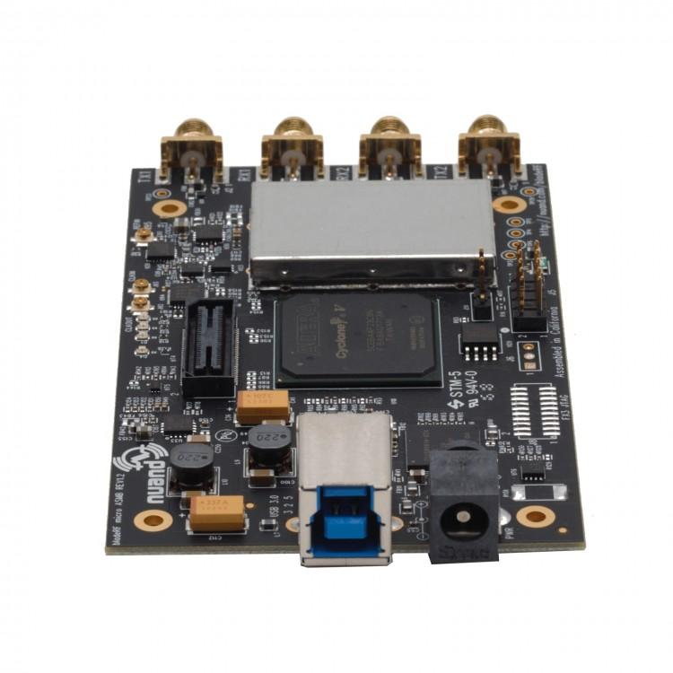
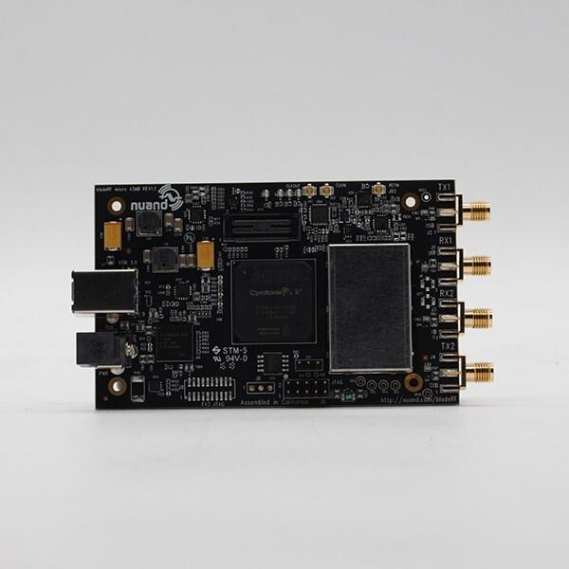
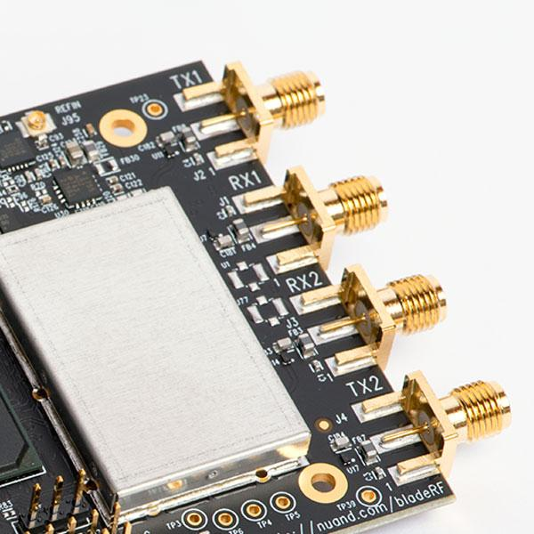
6
Nuand describes the bladeRF 2.0 micro as a 2×2 MIMO USB 3.0 SDR covering 47 MHz–6 GHz, with up to 61.44 MSPS sampling and 56 MHz filtered bandwidth.
Main technical specifications
Parameter | bladeRF 2.0 micro
Architecture | 2×2 MIMO
RX channels | 2
TX channels | 2
RX tuning range | 70 MHz–6 GHz
TX tuning range | 47 MHz–6 GHz
ADC/DAC resolution | 12-bit
Sample-rate range | 0.521–61.44 MSPS
Maximum filtered bandwidth | 56 MHz
Typical CW output | +8 dBm
USB | USB 3.0 SuperSpeed
FPGA | Intel/Altera Cyclone V E
FPGA variants | xA4, xA5, xA9
Clock | 38.4 MHz VCTCXO
External reference | Yes
Operating temperature | 0–70 °C
Dimensions | 6.3 × 10.2 × 1.8 cm
Weight | ~90 g

2. bladeRF 2.0 micro hardware architecture
The major signal path is:
RX1 SMA ─────┐
│
RX2 SMA ─────┤
▼
┌───────────┐
│ │
│ AD9361 │
│ RF │
│ Transceiver
│ │
└─────┬─────┘
│
I/Q data
│
▼
┌─────────────┐
│ Cyclone V E │
│ FPGA │
└──────┬──────┘
│
GPIF II
│
▼
┌─────────────┐
│ Cypress FX3│
│ USB 3.0 │
└──────┬──────┘
│
USB 3.0
│
▼
PC
The FPGA interfaces directly with the AD9361 RF transceiver and Cypress FX3 USB controller, while also interfacing with the clock system, VCTCXO trim circuitry, GPS/1-PPS and expansion header.

3. AD9361 RF transceiver
The Analog Devices AD9361 is the central RF component.
It provides:
- 2 RX channels
- 2 TX channels
- RF frequency synthesis
- RX/TX mixers
- programmable gain
- analog filtering
- ADCs
- DACs
- baseband interfaces
- I/Q data interfaces
Therefore:
Antenna
│
▼
RF front-end
│
▼
AD9361
┌──────┴──────┐
│ │
RX1 RX2
│ │
TX1 TX2
│ │
└──────┬──────┘
│
I/Q
│
▼
FPGA
Nuand specifically identifies the AD9361 as the integrated RF transceiver used in the bladeRF 2.0 micro.

4. Cyclone V FPGA
The second major component is the Intel/Altera Cyclone V E FPGA.
The bladeRF 2.0 micro is available with different FPGA capacities:
Model | FPGA capacity
xA4 | 49 kLE
xA5 | Intermediate capacity
xA9 | 301 kLE
The xA9 provides substantially more FPGA resources for custom DSP, FFTs, filters, demodulators, decoders and other hardware processing.
FPGA resources
For the published xA4–xA9 range:
- Logic elements: 49–301 kLE
- Embedded memory: 3,383–13,917 kbits
- Variable-precision DSP blocks: 66–342
- 18×18 multipliers: 132–684

5. Cypress FX3 USB controller
The bladeRF uses the Cypress FX3 USB 3.0 controller.
Its job is primarily to transfer high-speed I/Q data:
AD9361
↓
Cyclone V FPGA
↓
FX3
↓
USB 3.0
↓
Computer
The FX3 provides the USB 3.0 SuperSpeed connection to the host computer. Nuand's hardware description identifies the FX3 as one of the main devices in the architecture.

6. Clock system
The board uses a 38.4 MHz factory-calibrated VCTCXO.
Nuand specifies:
- 38.4 MHz reference
- factory calibration
- frequency taming capability
- 12-bit DAC control
- optional ADF4002 PLL-based taming
- synchronization/reference interfaces
The FPGA also interfaces with the clock generator and VCTCXO trim circuitry.

7. Flash memory
The SPI flash stores important device information.
For the bladeRF 2.0 micro:
Model | Flash | Voltage
xA4 | W25Q32JVSSIQ | 3.3 V
xA9 | W25Q128JVSSIQ | 3.3 V
The flash can contain:
- FX3 firmware
- calibration data
- FPGA autoload metadata
- FPGA bitstream
- device information
Nuand documents the flash layout and individual flash part numbers.

8. Nios II processor
The FPGA can contain an Intel Nios II soft processor.
It is used for board control and management rather than replacing the host computer.
The FPGA architecture handles:
- RFIC control
- clock control
- GPIO
- I/Q sample handling
- USB data path
- peripheral management

9. RF connectors
The bladeRF 2.0 micro provides:
RX1 ───── SMA
RX2 ───── SMA
TX1 ───── SMA
TX2 ───── SMA
This gives the board its 2×2 MIMO architecture.

10. Expansion and synchronization hardware
The FPGA also connects to the expansion interface.
The hardware architecture provides interfaces for:
- GPIO
- external control
- GPS-related NMEA input
- 1-PPS synchronization
- reference clock
- expansion boards
Nuand's HDL documentation explicitly identifies the GPS NMEA, 1-PPS, reference-clock and expansion-header connections.

11. Power system
The bladeRF 2.0 micro can operate from:
- USB 3.0 power
- external 5-V DC input
The board includes power-management circuitry that automatically selects between USB bus power and external DC power.

12. Complete major-component list
bladeRF 2.0 micro
Section | Component
RF transceiver | Analog Devices AD9361
FPGA | Intel/Altera Cyclone V E
USB controller | Cypress EZ-USB FX3
Reference oscillator | 38.4 MHz VCTCXO
VCTCXO control | 12-bit DAC / taming circuitry
Optional clock taming | ADF4002 PLL
Flash xA4 | Winbond W25Q32JVSSIQ
Flash xA9 | Winbond W25Q128JVSSIQ
FPGA CPU | Nios II soft processor
RF connectors | SMA
RF switching | RF switch network
RF filtering | RF filters/matching networks
Power | USB + 5-V DC power circuitry
Synchronization | Reference / 1-PPS
Expansion | GPIO/expansion header

13. bladeRF 1.x / Classic
The original bladeRF is substantially different.
Technical specifications
Parameter | bladeRF Classic
RF range | 300 MHz–3.8 GHz
RX | 12-bit
TX | 12-bit
Sample rate | Up to 40 MSPS
Full-duplex bandwidth | Up to 28 MHz
RF transceiver | LMS6002D
FPGA | Cyclone IV E
FPGA variants | x40 / x115
USB | USB 3.0 SuperSpeed
Clock | 38.4 MHz VCTCXO
Clock generator | Si5338
USB controller | Cypress FX3
CPU | ARM9 inside FX3
MIMO | 2×2 possible
Expansion | GPIO/expansion connector

14. bladeRF Classic components
RX/TX SMA
│
▼
RF switching
│
▼
┌────────────┐
│ LMS6002D │
│ RFIC │
└─────┬──────┘
I/Q
│
▼
┌────────────┐
│ Cyclone IV │
│ E FPGA │
└─────┬──────┘
│
GPIF II
│
▼
┌────────────┐
│ Cypress │
│ FX3 │
└─────┬──────┘
│
USB 3.0
The Classic FPGA also controls the Si5338 clock generator, VCTCXO DAC, RF switches and expansion interface.

15. x40 vs x115
The two Classic models primarily differ in FPGA capacity:
Model | FPGA
bladeRF x40 | Cyclone IV E, ~40K logic elements
bladeRF x115 | Cyclone IV E, ~115K logic elements
Nuand notes that FPGA size is the key difference between x40 and x115 within the same generation.

16. BladeRF generation comparison
Feature | bladeRF x40/x115 | bladeRF 2.0 micro
RF transceiver | LMS6002D | AD9361
Frequency | 300 MHz–3.8 GHz | 47 MHz–6 GHz TX / 70 MHz–6 GHz RX
ADC/DAC | 12-bit | 12-bit
Max sample rate | 40 MSPS | 61.44 MSPS
Bandwidth | 28 MHz | 56 MHz
MIMO | 2×2 | 2×2
FPGA | Cyclone IV E | Cyclone V E
USB | USB 3.0 | USB 3.0
Clock | 38.4 MHz | 38.4 MHz
Main RF architecture | LMS6002D | AD9361
Most important documents for component-level study
For a serious bladeRF hardware technical reference, I would collect these in this order:
- bladeRF 2.0 micro schematic
- bladeRF 2.0 micro BOM
- AD9361 datasheet
- Cyclone V E datasheet
- Cypress FX3 datasheet
- VCTCXO datasheet
- Clock/PLL documentation
- SPI flash datasheet
- bladeRF FPGA HDL
- FX3 firmware source
- libbladeRF documentation
- bladeRF hardware revision documentation
Nuand makes the schematics, HDL, firmware and software available as open-source material, making bladeRF one of the better SDRs for component-level hardware study.

